

**MVPS’s**

**RAJARSHI SHAHU MAHARAJ POLYTECHNIC,**

**NASHIK**

**COMPUTER TECHNOLOGY DEPARTMENT.**

**ACADEMIC YEAR 2020-2021**

**MICROPROCESSOR (22415)**

MICRO-PROJECT

ON

**“Develop a Program to Generate Fibonacci Series”**

SUBMITTED BY

|  |  |  |  |
| --- | --- | --- | --- |
| **SR. NO** | **ENROLLMENT NO** | **EXAM SEAT NO** | **STUDENT NAME** |
| 1 | 1610020163 |  | Wani Pushpak Shrikant |
| 2 | 1910020360 |  | Raut Atharva Satish |
| 3 | 1910020362 |  | Savant Omkar Vitthal |



MAHARASHTRA STATE BOARD OF TECHNICAL EDUCATION

Certificate

This is to certify that Ms./Mr. Savant Omkar Vitthal______________________

Roll No.__45_ of 4th semester of Diploma in **Computer Technology** of Institute **MVPS’s Rajarshi Shahu Maharaj Polytechnic, Nasik (Code: 1002)** has successfully completed micro-project in **MICROPROCESSOR (22415)** for academic year 2020-21 as prescribed in curriculum of MSBTE, Mumbai.

|  |  |
| --- | --- |
| Place: Nasik | Enrollment no.:1910020362 |
| Date:…………. | Exam seat no:…………………... |

|  |  |  |
| --- | --- | --- |
| **Prof. R. S. Derle** | **Prof. P. D. Boraste** | **Dr. D. B. Uphade** |
| **Course Teacher/Guide** | **H.O.D** | **Principal** |

|  |  |
| --- | --- |
| E:\NBA DATA\photo.jpg | **MVPS’s RAJARSHI SHAHU MAHARAJ POLYTECHNIC,NASIK** |
| **Institute Code: 1002** |
| **COMPUTER TECHNOLOGY DEPARTMENT** |

**Log Book for Micro Project**

|  |  |
| --- | --- |
| **Academic Year : 2020-21** | **Scheme: I** |
| **Semester : IV** | **Class: SYCM** |
| **Name of Course : MICROPROCESSOR (MIC)** | **Course Code: 22415** |

**Title of the project:** Develop a Program to Generate Fibonacci Series

**Group Members:**

|  |  |  |  |  |  |
| --- | --- | --- | --- | --- | --- |
| **Sr.No.** | **Roll No.** | **Enrollment Number** | **Exam Seat No.** | **Name of the Student** | **Signature of student** |
| 1 | 1 | 1610020163 |  | Wani Pushpak Shrikant |  |
| 2 | 43 | 1910020360 |  | Raut Atharva Satish |  |
| 3 | 45 | 1910020362 |  | Savant Omkar Vitthal |  |

**Project Reporting:**

|  |  |  |  |  |  |  |
| --- | --- | --- | --- | --- | --- | --- |
| **Sr. No.** | **Date** | **Discussion & details** | | **Group members present** | **Teacher’s comment/ remark** | **Signature of teacher** |
| 1 | 31-03-2021 | Formation of groups | |  |  |  |
| 2 | 31-03-2021 | Discussion on concept of Micro Project | |  |  |  |
| 3 | 07-04-2021 | Topic selection for the Micro Project | |  |  |  |
| 4 | 07-04-2021 | Preliminary discussion with guide | |  |  |  |
| 5 | 14-04-2021 | Submission of Micro Project proposal | |  |  |  |
| 6 | 14-04-2021 | Information Gathered | |  |  |  |
| 7 | 21-04-2021 | Literature survey (Introduction) | |  |  |  |
| 8 | 21-04-2021 | Discussion with guide | |  |  |  |
| 9 | 28-04-2021 | Design of GUI and output | |  |  |  |
| 10 | 05-05-2021 | Code generation of modules | |  |  |  |
| 11 | 12-05-2021 | Error Evaluation | |  |  |  |
| 12 | 19-05-2021 | Merging of all individual modules into one single module | |  |  |  |
| 13 | 26-05-2021 | Draft copy of report. | |  |  |  |
| 14 | 02-06-2021 | Final report writing | |  |  |  |
| 15 | 09-06-2021 | Presentation & oral | |  |  |  |
| 16 | 16-06-2021 | Final submission | |  |  |  |
| E:\NBA DATA\photo.jpg | | | **MVPS’s RAJARSHI SHAHU MAHARAJ POLYTECHNIC,NASIK** | | | | |
| **Institute Code: 1002** | | | | |
| **COMPUTER TECHNOLOGY DEPARTMENT** | | | | |

**Rubrics for Evaluation of Micro Project**

|  |  |
| --- | --- |
| **Academic Year: 2020-21** | **Scheme: I** |
| **Semester: IV** | **Class: SYCM** |
| **Name of Course: MICROPROCESSOR (MIC)** | **Course Code: 22415** |

**Group Members:**

|  |  |  |  |  |  |
| --- | --- | --- | --- | --- | --- |
| **Sr.No.** | **Roll No.** | **Enrollment Number** | **Exam Seat No.** | **Name of the Student** | **Signature of student** |
| **1** | 1 | 1610020163 |  | Wani Pushpak Shrikant |  |
| **2** | 43 | 1910020360 |  | Raut Atharva Satish |  |
| **3** | 45 | 1910020362 |  | Savant Omkar Vitthal |  |

|  |  |  |  |  |  |  |  |
| --- | --- | --- | --- | --- | --- | --- | --- |
| **Sr.No.** | **Criteria** | **Indicators of different levels of performance** | | | | | **Marks obtained** |
| **Poor**  **(01)** | **Satisfactory**  **(02)** | **Good**  **(03)** | **Very**  **Good**  **(04)** | **Excellent**  **(05)** |
| **1** | **Selection Of Application (Programming Elements)** |  |  |  |  |  |  |
| **2** | **Concept/ Content/ Function Descriptions** |  |  |  |  |  |  |
| **3** | **Coding** |  |  |  |  |  |  |
| **4** | **Error solving** |  |  |  |  |  |  |
| **5** | **Timely Submission** |  |  |  |  |  |  |
| **Total marks Out of 25** | | | | | | |  |
| **Marks Out of 6** | | | | | | |  |

|  |  |
| --- | --- |
|  | **Prof. R. S. Derle** |
|  | **Name & Signature of Course Teacher/Guide** |
|  |  |

|  |  |
| --- | --- |
| E:\NBA DATA\photo.jpg | **MVPS’s RAJARSHI SHAHU MAHARAJ POLYTECHNIC,NASIK** |
| **Institute Code: 1002** |
| **COMPUTER TECHNOLOGY DEPARTMENT** |

**ANNEXTURE II**

|  |  |  |
| --- | --- | --- |
| **Academic Year:** **2020-21** | **Name of Faculty:** **Mr. R .S. Derle** | |
| **Course:** **MICROPROCESSOR (MIC)** | **Course code:** **22415** | **Semester:** IV |

**Title of the project:** Develop a Program to Generate Fibonacci Series

**COs addressed by the Micro Project:**

**CO-415.1** Analyze the functional block of 8086 microprocessor.

**CO-415.2** Write assembly language program for the given problem.

**CO-415.3** Use instructions for different addressing modes.

**CO-415.4** Develop an assembly language program using assembler.

**CO-415.5** Develop an assembly language program using procedures, micros and

modular programming approach.

**Major learning Outcomes achieved by students by doing the Project:**

1. **Practical Outcomes** ……………………………………………………………………………………………………………………………………………………………………………………………………
2. **Unit outcomes in cognitive domain** ……………………………………………………………………………………………………………………………………………………………………………………………………
3. **Outcomes in affective domain** ……………………………………………………………………………………………………………………………………………………………………………………………………

**Comment/Suggestions about team work/leadership/inter-personal communication (if any)** …………………………………………………………………………………………………………………………………………………………………………………………………………………………

|  |  |  |  |  |  |  |
| --- | --- | --- | --- | --- | --- | --- |
| **Roll. No.** | **Enrollment no** | **Exam seat no** | **Student Name** | **Marks out of 6 for performance in group activity** | **Marks out of 4 for performance oral/ presentation** | **Total out of 10** |
| 1 | 1610020163 |  | Wani Pushpak Shrikant |  |  |  |
| 43 | 1910020360 |  | Raut Atharva Satish |  |  |  |
| 45 | 1910020362 |  | Savant Omkar Vitthal |  |  |  |

|  |  |  |
| --- | --- | --- |
| **Prof. R. S. Derle** |  | **Prof. P. D. Boraste** |
| **Course Teacher/Guide** |  | **H.O.D** |

**INDEX**

|  |  |  |
| --- | --- | --- |
| Sr.No. | Topic | Page No. |
| 1 | Abstract | 2 |
| 2 | Introduction   1. Microprocessor 2. 8086 Microprocessor 3. Assembly Language Programming | 3-6  3  4  6 |
| 3 | History   1. Microprocessor 2. 8086 Microprocessor 3. Assembly Language Programming | 7-9  7  8  9 |
| 4 | Code | 10 |
| 5 | Output | 11-13 |
| 6 | Application | 14 |
| 7 | Conclusion | 15 |
| 8 | References | 16 |

**Abstract**

This paper is scrutinizes the use of different terms and syntaxes in Microprocessor, enabling viewer to get the complete concept of different aspects of Microprocessor To satisfy this we created a Assembly Language Program displaying Fibonacci series. Use of various syntaxes was used as a reference to the output, satisfying every need of a perfect Asssembly Language Program.

**Introduction**

1. **Microprocessor:**

A microprocessor is a computer processor where the data processing logic and control is included on a single integrated circuit, or a small number of integrated circuits. The microprocessor is a multipurpose, clock-driven, register-based, digital integrated circuit that accepts binary data as input, processes it according to instructions stored in its memory, and provides results (also in binary form) as output. Microprocessors contain both combinational logic and sequential digital logic. Microprocessors operate on numbers and symbols represented in the binary number system.

The integration of a whole CPU onto a single or a few integrated circuits using Very-Large-Scale Integration (VLSI) greatly reduced the cost of processing power. Integrated circuit processors are produced in large numbers by highly automated metal-oxide-semiconductor (MOS) fabrication processes, resulting in a relatively low unit price. As microprocessor designs improve, the cost of manufacturing a chip (with smaller components built on a semiconductor chip the same size) generally stays the same according to Rock's law.

Before microprocessors, small computers had been built using racks of circuit boards with many medium- and small-scale integrated circuits, typically of TTL type. Microprocessors combined this into one or a few large-scale ICs. The first commercially-available microprocessor was the Intel 4004.

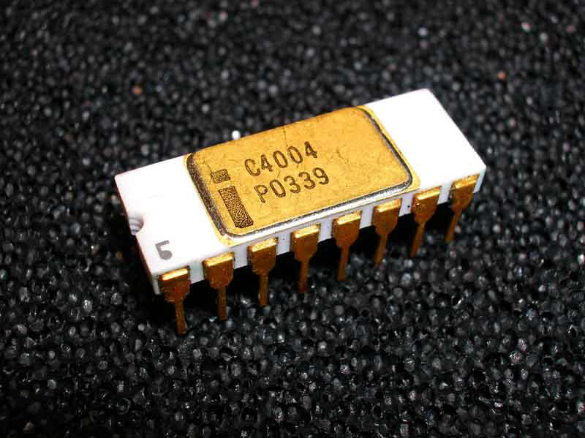

Fig.1. Microprocessor – Intel 4004

1. **8086 Microprocessor:**

The 8086 (also called iAPX 86) is a 16-bit microprocessor chip designed by Intel between early 1976 and June 8, 1978, when it was released. The Intel 8088, released July 1, 1979, is a slightly modified chip with an external 8-bit data bus (allowing the use of cheaper and fewer supporting ICs), and is notable as the processor used in the original IBM PC design.

The 8086 gave rise to the x86 architecture, which eventually became Intel's most successful line of processors. On June 5, 2018, Intel released a limited-edition CPU celebrating the 40th anniversary of the Intel 8086, called the Intel Core i7-8086K.

All internal registers, as well as internal and external data buses, are 16 bits wide, which firmly established the "16-bit microprocessor" identity of the 8086. A 20-bit external address bus provides a 1 MB physical address space (220 = 1,048,576). This address space is addressed by means of internal memory "segmentation". The data bus is multiplexed with the address bus in order to fit all of the control lines into a standard 40-pin dual in-line package. It provides a 16-bit I/O address bus, supporting 64 KB of separate I/O space. The maximum linear address space is limited to 64 KB, simply because internal address/index registers are only 16 bits wide.

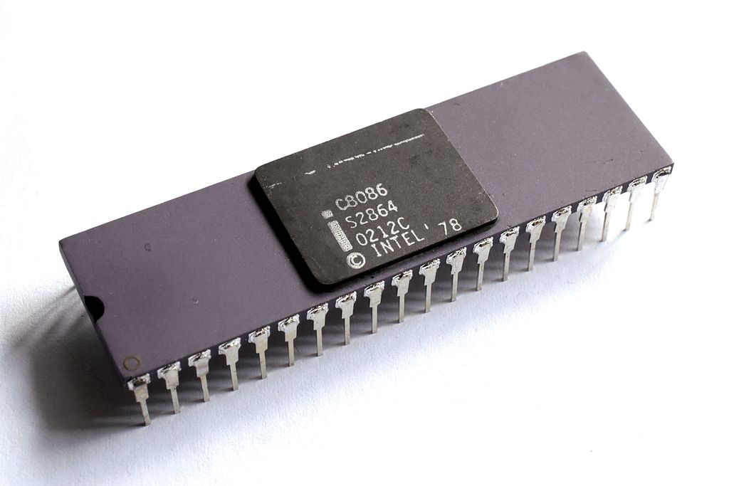

Fig.2. Intel 8086 Microprocessor

**8086 Microprocessor Pin Diagram:**

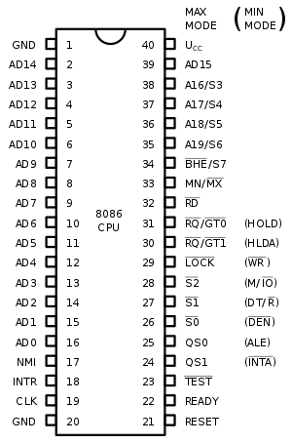

Fig.3. 8086 Pin Diagram

1. **Assembly Language Programming:**

In computer programming, assembly language (or assembler language), often abbreviated asm, is any low-level programming language in which there is a very strong correspondence between the instructions in the language and the architecture's machine code instructions. Because assembly depends on the machine code instructions, every assembly language is designed for exactly one specific computer architecture. Assembly language may also be called symbolic machine code.

Assembly code is converted into executable machine code by a utility program referred to as an assembler. The conversion process is referred to as assembly, as in assembling the source code. Assembly language usually has one statement per machine instruction (1:1), but comments and statements that are assembler directives, macros, and symbolic labels of program and memory locations are often also supported.The term "assembler" is generally attributed to Wilkes, Wheeler and Gill in their 1951 book The Preparation of Programs for an Electronic Digital Computer, who, however, used the term to mean "a program that assembles another program consisting of several sections into a single program".

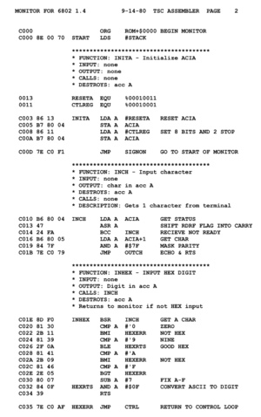

Fig.4. Assembly Language Program

**History**

1. **Microprocessor:**

The microprocessor has origins in the development of the MOSFET (metal-oxide-semiconductor field-effect transistor), which was first demonstrated by Mohamed M. Atalla and Dawon Kahng of Bell Labs in 1960.Following the development of MOS integrated circuit chips in the early 1960s, MOS chips reached higher transistor density and lower manufacturing costs than bipolar integrated circuits by 1964. The application of MOS LSI chips to computing was the basis for the first microprocessors, as engineers began recognizing that a complete computer processor could be contained on several MOS LSI chips Designers in the late 1960s were striving to integrate the central processing unit functions of a computer onto a handful of MOS LSI chips, called microprocessor unit (MPU) chipsets.

The first commercially produced microprocessor was the Intel 4004, released as a single MOS LSI chip in 1971. The single-chip microprocessor was made possible with the development of MOS silicon-gate technology (SGT). The 4004 was designed for Busicom, which had earlier proposed a multi-chip design in 1969, before Faggin's team at Intel changed it into a new single-chip design. Intel introduced the first commercial microprocessor, the 4-bit Intel 4004, in 1971. It was soon followed by the 8-bit microprocessor Intel 8008 in 1972.

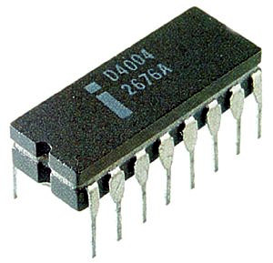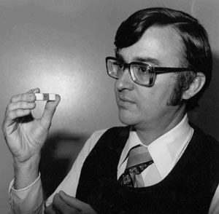

Fig.5. Marcian Hoff Fig.6. 4004 Microprocessor

1. **8086:**

In 1972, Intel launched the 8008, the first 8-bit microprocessor. It implemented an instruction set designed by Datapoint corporation with programmable CRT terminals in mind, which also proved to be fairly general-purpose. The device needed several additional ICs to produce a functional computer, in part due to it being packaged in a small 18-pin "memory package", which ruled out the use of a separate address bus (Intel was primarily a DRAM manufacturer at the time).

Two years later, Intel launched the 8080, employing the new 40-pin DIL packages originally developed for calculator ICs to enable a separate address bus. It has an extended instruction set that is source-compatible (not binary compatible) with the 8008[5] and also includes some 16-bit instructions to make programming easier. The 8080 device was eventually replaced by the depletion-load-based 8085 (1977), which sufficed with a single +5 V power supply instead of the three different operating voltages of earlier chips. Other well known 8-bit microprocessors that emerged during these years are Motorola 6800 (1974), General Instrument PIC16X (1975), MOS Technology 6502 (1975), Zilog Z80 (1976), and Motorola 6809 (1978).

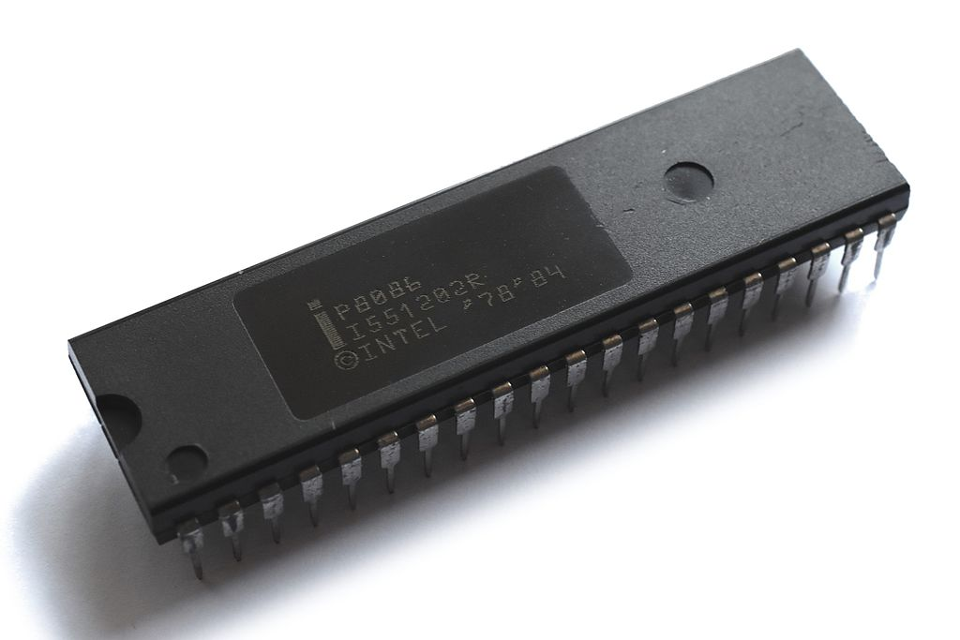

Fig.7. Intel P8086

1. **Assembly Language Programming:**

In late 1948, the Electronic Delay Storage Automatic Calculator (EDSAC) had an assembler (named "initial orders") integrated into its bootstrap program. It used one-letter mnemonics developed by David Wheeler, who is credited by the IEEE Computer Society as the creator of the first "assembler". Reports on the EDSAC introduced the term "assembly" for the process of combining fields into an instruction word. SOAP (Symbolic Optimal Assembly Program) was an assembly language for the IBM 650 computer written by Stan Poley in 1955.

Assembly languages eliminate much of the error-prone, tedious, and time-consuming first-generation programming needed with the earliest computers, freeing programmers from tedium such as remembering numeric codes and calculating addresses.Assembly languages were once widely used for all sorts of programming. However, by the 1980s (1990s on microcomputers), their use had largely been supplanted by higher-level languages, in the search for improved programming productivity. Today, assembly language is still used for direct hardware manipulation, access to specialized processor instructions, or to address critical performance issues. Typical uses are device drivers, low-level embedded systems, and real-time systems.

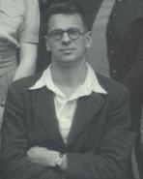

Fig.8. David Wheeler

**Code**

;Declaration Part

.MODEL SMALL

.DATA

RES DB ?

CNT DB 0AH ; Initialize the counter for the no of Fibonacci No needed

.CODE

START: MOV AX,@DATA

MOV DS,AX

LEA SI,RES

MOV CL,CNT ; Load the count value for CL for looping

MOV AX,00H ; Default No

MOV BX,01H ; Default No

;Fibonacci Part

L1:ADD AX,BX

MOV [SI],AX

MOV AX,BX

MOV BX,[SI]

INC SI

LOOP L1

INT 3H ; Terminate the Program

END START

**Output**

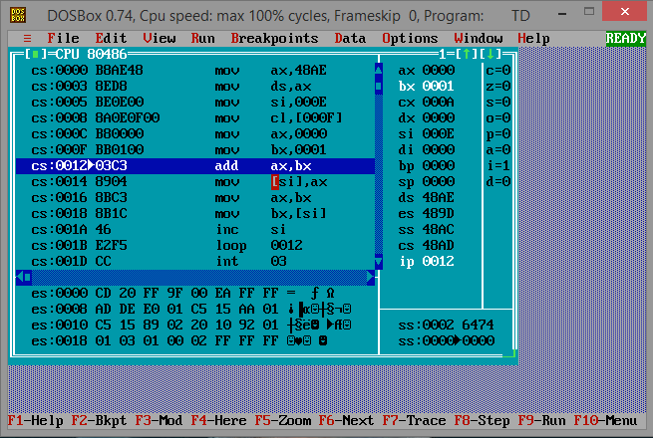

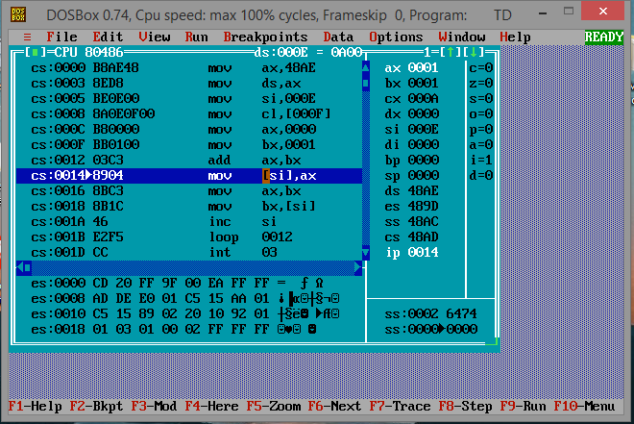

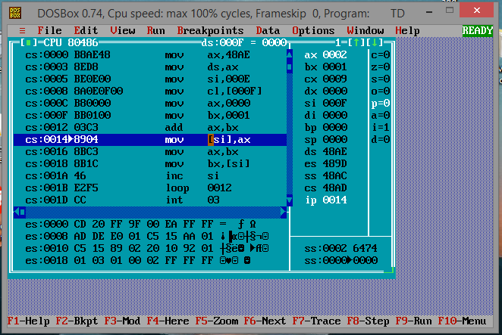

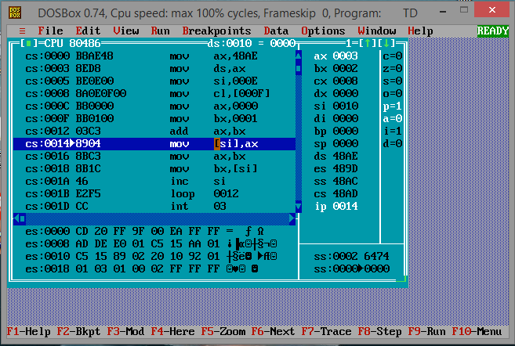

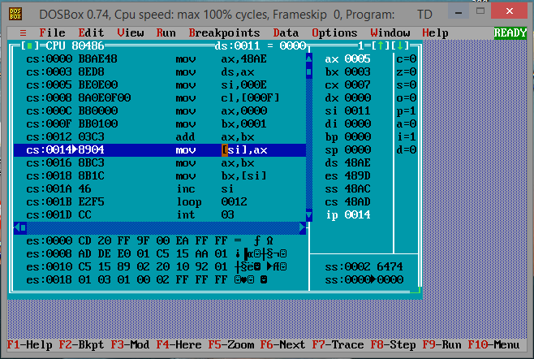

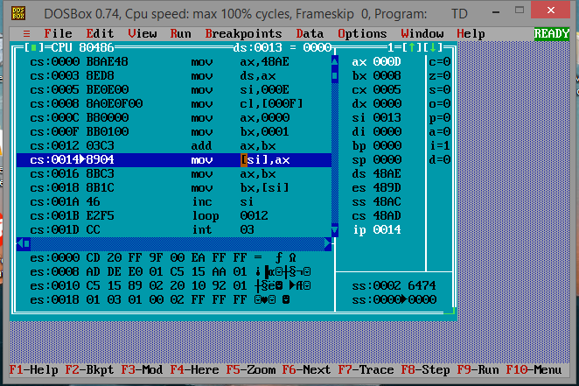

**Applications**

Thousands of items that were traditionally not computer-related include microprocessors. These include household appliances, vehicles (and their accessories), tools and test instruments, toys, light switches/dimmers and electrical circuit breakers, smoke alarms, battery packs, and hi-fi audio/visual components (from DVD players to phonograph turntables). Such products as cellular telephones, DVD video system and HDTV broadcast systems fundamentally require consumer devices with powerful, low-cost, microprocessors.

Increasingly stringent pollution control standards effectively require automobile manufacturers to use microprocessor engine management systems to allow optimal control of emissions over the widely varying operating conditions of an automobile. Non-programmable controls would require bulky, or costly implementation to achieve the results possible with a microprocessor.

A microprocessor control program (embedded software) can be tailored to fit the needs of a product line, allowing upgrades in performance with minimal redesign of the product. Unique features can be implemented in product line's various models at negligible production cost.

Microprocessor control of a system can provide control strategies that would be impractical to implement using electromechanical controls or purpose-built electronic controls. For example, an internal combustion engine's control system can adjust ignition timing based on engine speed, load, temperature, and any observed tendency for knocking—allowing the engine to operate on a range of fuel grades.

The programmable thermostat allows the control of temperature at homes. In this system, a microprocessor works with the temperature sensor to determine and adjust the temperature accordingly.

High-end coffee makers, Washing machines, and radio clocks contain microprocessor technology.

Some other home items that contain microprocessors are: microwaves, toasters, televisions, VCRs, DVD players, ovens, stoves, clothes washers, stereo systems, home computers, alarm clocks, hand-held game devices, thermostats, video game systems, bread machines, dishwashers, home lighting systems and even some refrigerators with digital temperature control.

**Conclusion**

Before microprocessors, small computers had been built using racks of circuit boards with many medium- and small-scale integrated circuits, typically of TTL type. Microprocessors combined this into one or a few large-scale ICs. The first commercially-available microprocessor was the Intel 4004.

Continued increases in microprocessor capacity have since rendered other forms of computers almost completely obsolete (see history of computing hardware), with one or more microprocessors used in everything from the smallest embedded systems and handheld devices to the largest mainframes and supercomputers.

The 8086 gave rise to the x86 architecture, which eventually became Intel's most successful line of processors. On June 5, 2018, Intel released a limited-edition CPU celebrating the 40th anniversary of the Intel 8086, called the Intel Core i7-8086K.

The term "assembler" is generally attributed to Wilkes, Wheeler and Gill in their 1951 book The Preparation of Programs for an Electronic Digital Computer, who, however, used the term to mean "a program that assembles another program consisting of several sections into a single program".

The computational step when an assembler is processing a program is called assembly time.

**References**

1. <https://en.wikipedia.org/wiki/Microprocessor#Embedded_applications>
2. <https://en.wikipedia.org/wiki/Intel_8086#Background>
3. <https://en.wikipedia.org/wiki/Assembly_language#Assembly_language_syntax>
4. <https://www.javatpoint.com/microprocessor-applications>